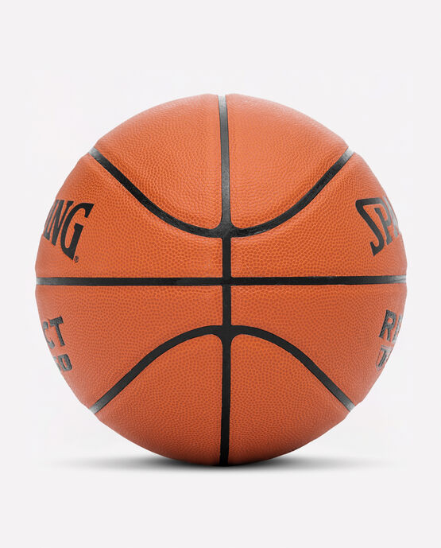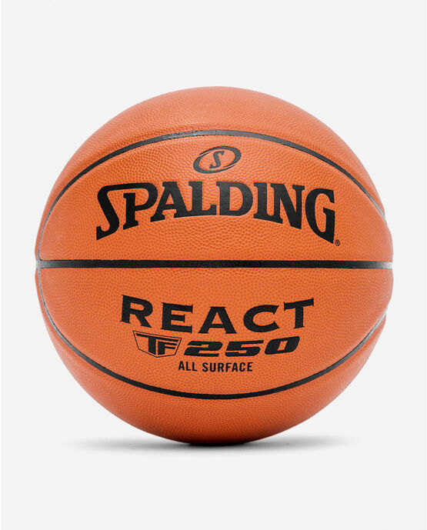

SPALDING’S REACT TF-250 BASKETBALL

The court is a canvas and the ball is your brush. Unlock the creativity of this beautiful game with the Spalding REACT TF-250 All Surface Basketball. Spalding’s iconic grip will have you in control of your game at all times. Whether it’s the behind-the-back pass you’ve been perfecting or the last second half court heave you’ve been practicing, the REACT TF-250 is ready to ball at all times. Its all surface performance composite cover guarantees that you’re set no matter when or where the game is. The game is calling. Answer the call with the Spalding REACT TF-250.

**DETAILS:**

* GRIP IT: All surface performance composite cover gives the ball a solid grip for total control.
* SHOOTER’S TOUCH: Spalding Shooter’s Seam is designed for instant ball recognition, exceptional control, and precise accuracy.
* ALL SURFACE PLAY: From the driveway to the gym and everywhere in between.
* OFFICIAL SIZE: Size 7, 29.5" or INTERMEDIATE SIZE: Size 6, 28.5" or YOUTH SIZE: Size 5, 27.5" available.
* SHIPPED INFLATED: Game-ready feel straight out of the box. Inflation recommendation is 8 PSI.